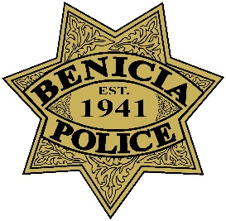
AUTOMATED LICENSE PLATE READERS
DATA SHARING ACKNOWLEDGMENT LETTER

This letter is to certify that the (AGENCY NAME) has requested to receive data from the Benicia Police Department’s Automated License Plate Readers Program.
Data shared by the Benicia Police Department will only be used for law enforcement purposes ONLY, and not for other purposes such as immigration, personal use, harassment, and any other usages that are against the Benicia Police Department’s policy.
By signing this letter, the representatives of (AGENCY NAME) agree to abide by this policy.

___________________
(Signature/Print name)
___________________
(Title/Rank)
___________________
(Date)

